Week -6

#1 Write a C++ Program for Add Two Numbers Using Pointer.

This is the required program:

#include <iostream>

using namespace std;

int main()

{

    float a, b, add;

    float *ptr_a, *ptr_b, *ptr_add;

    cout << "Enter two numbres\n";

    cin >> a >> b;

    ptr_a = &a;

    ptr_b = &b;

    add = *ptr_a + *ptr_b;

    cout << "\nThe sum of both numbers: " << add;

}

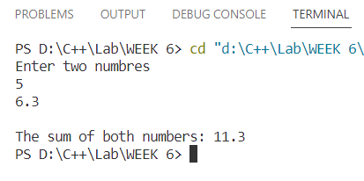And this is result:

#2 Write a C++ Example Program for Swap Numbers Using Pointers.

This is the required code:

#include <iostream>

using namespace std;

float swap(float *a, float *b)

{

    float temp;

   temp = *a;

   *a = *b;

   *b = temp;

}

int main()

{

    float x, y, *ptr_x, *ptr_y;

    ptr_x = &x;

    ptr_y = &y;

    cout << "Enter two numbers\n";

    cin >> x >> y;

    cout << "Value of x and y before swapping: " << x << "    " << y<<endl;

    swap(ptr_x, ptr_y);

    cout << "Value of x and y after swapping: " << x << "    " << y;

}

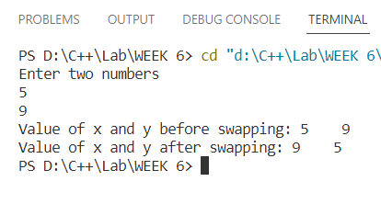And this is the output:

#3 Write a C++ Program to Print the address of the Variable Using a Pointer.

This is the required program:

#include <iostream>

using namespace std;

int main()

{

    int *ptr_a, a,b;

    ptr_a = &b;

    ptr_a = &a;

    cout<<"The address of the variable is "<<ptr_a;

}

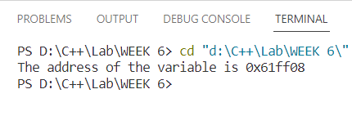And this is the result:

#4 Write a C++ Program for Increment and Decrement Integer Using Pointer.

This is the required code:

#include<iostream>

using namespace std;

int main()

{

    float a, *ptr_a;

    cout<<"Enter a number: ";

    cin>>a;

    ptr_a = &a;

    *ptr_a = *ptr_a +1;

    cout<<"Incremented value: "<<*ptr_a<< endl;

     *ptr_a = *ptr_a-3;

     cout<<"Decremented value: "<<*ptr_a;

}

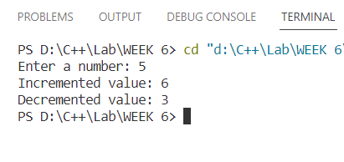And this is the result:

#5 Write a C++ Program for Print String Using Pointer.

This is the required code:

#include <iostream>

using namespace std;

int main()

{

    char mystr[1000];

    cout << "Enter any string: ";

    cin.getline(mystr , 1000);

    char *ptr;

    ptr = &mystr[0];

    cout<<mystr;

}

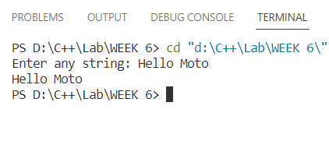And this is output:

#6 Write a C++ program to concatenate two strings using pointers.

This is the required program:

#include <iostream>

using namespace std;

void concatenateStrings(char *str1, const char *str2)

{

    // Move the pointer to the end of str1

    while (*str1)

        str1++;

    // Copy characters from str2 to str1

    while (*str2)

    {

        *str1 = *str2;

        str1++;

        str2++;

    }

    // Add null terminator to str1

    *str1 = '\0';

}

int main()

{

    char str1[100], str2[100];

    cout << "Enter the first string: ";

    cin.getline(str1, sizeof(str1));

    cout << "Enter the second string: ";

    cin.getline(str2, sizeof(str2));

    concatenateStrings(str1, str2);

    cout << "Concatenated string: " << str1 << endl;

    return 0;

And this is the output:

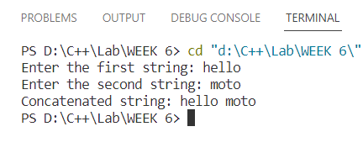

#7 Write a program for reading elements using a pointer into an array and display the values using an array.

1. Declare a set of elements.
2. Declare the pointer and initialize it to the first element address of a set of elements(array).

This is the required code:

#include <iostream>

using namespace std;

int main()

{

    // declaring a set of elements

    int arr[] = {1, 5, 9, 41, 56, 75, 19, 45, 46};

    int *ptr = &arr[0];

    // Display the values using array indexing

    cout << "array elements are : ";

    for (int i = 0; i < sizeof(arr) / sizeof(arr[0]); i++)

        cout << *(ptr + i) << " ";

    cout << endl;

    return 0;

}

And this is the result:

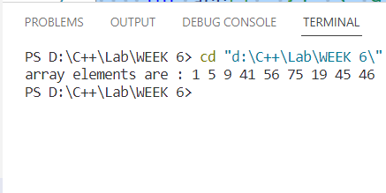

#8 Write a program through a pointer variable to the sum of n elements from the array.

This the result:

#include <iostream>

using namespace std;

int main()

{

    int n;

    cout<<"Enter the size of the array : ";

    cin>>n;

    float arr[n], sum=0;

    float *ptr = &arr[0];

    cout<<"Enter elements of the array\n";

    for (int i = 0; i < n; i++)

    {

        cin>>*(ptr+i);

        sum+=*(ptr+i);

    }

    cout<<"The sum of the elements is: "<<sum;

}

And this is the result:

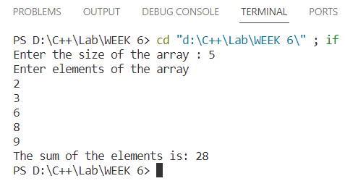

#9 Write a program for reading elements using a pointer into the array and display the values using an array.

This is the required program:

#include <iostream>

using namespace std;

int main()

{

    int n;

    cout << "Enter the size of the array : ";

    cin >> n;

    int arr[n];

    int *ptr = arr;

    for (int i = 0; i < n; i++)

    {

        cout << "Enter element " << i + 1 << ": ";

        cin >> *(ptr + i);

    }

    cout << "Entered elements: ";

    // Display the values using array indexing

    for (int i = 0; i < n; i++)

        cout << arr[i] << " ";

    cout << endl;

    return 0;

}

And this is the output:

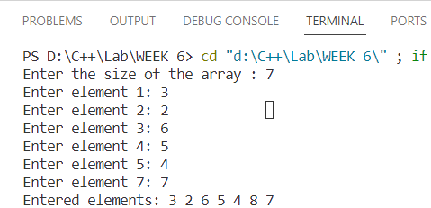

#10 Write a C++ program to reverse a string using pointers.

This is the required code:

#include <iostream>

#include <cstring>

using namespace std;

void reversestr(char *str)

{

    int length = strlen(str);

    char *start = str;

    char *end = str + length - 1;

    while (start < end)

    {

        char temp = *start;

        *start = *end;

        *end = temp;

        end--;

        start++;

    }

}

int main()

{

    char str[1000];

    cout << "Enter any string : ";

    cin.getline(str, sizeof(str));

    // cout<<strlen(str);

    // cout<<sizeof(str)<<endl;

    reversestr(str);

    cout << str;

}

And this is the result:

